Final Exam

|  |  |  |
| --- | --- | --- |
| # | Full Name | Group |
| 1 | Mukhamedzhan Gabituly | CS-2122 |
| 2 | Elnur Khamzin | CS-2122 |
| 3 | Nazerke Adilgali | CS-2122 |
|  |  |  |

|  |
| --- |
| Link to the repository: <https://github.com/gabituly-m/OS_FINAL.git> |

Step-by-step task completion:

Task 1:

Screenshots of the code compilation result:

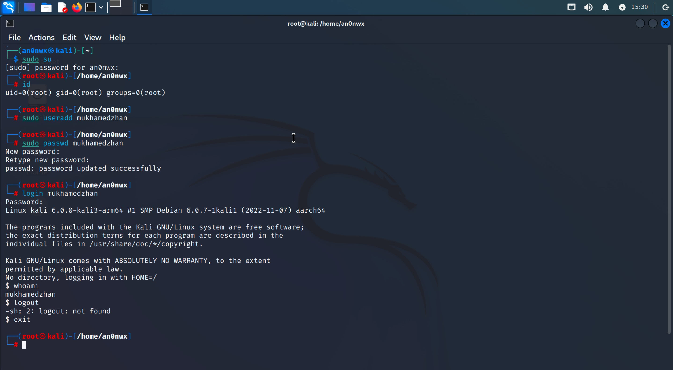

Task 2:

Screenshots of the code compilation result:

**Direct IP Connection:**

1. **Assign a public IP address directly to the virtual machine.**

For example, we will choose google.com domain (ip - 142.250.180.110)

1. **This approach necessitates the virtual machine to possess its own publicly accessible IP address, which may not always be attainable since public IP addresses are a scarce resource.**
2. **The virtual machine can then access the Internet directly.**

So, we can verify it using ping command by sending our traffic packets to this public ip.

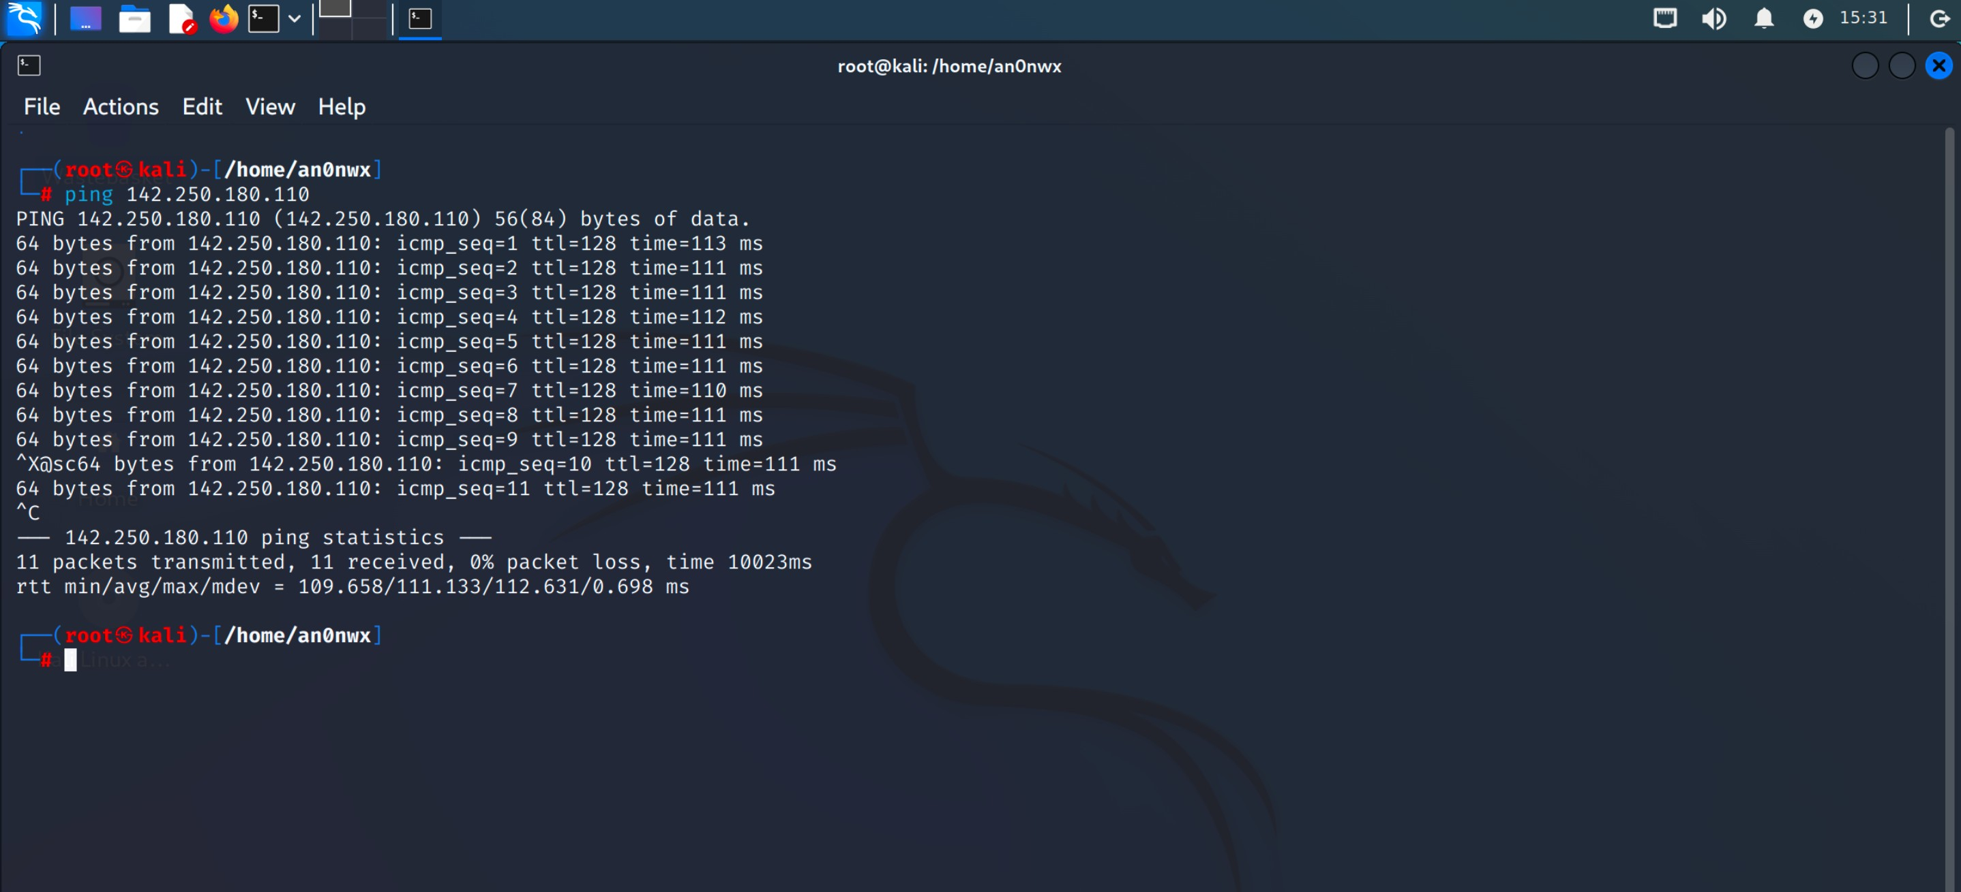

v

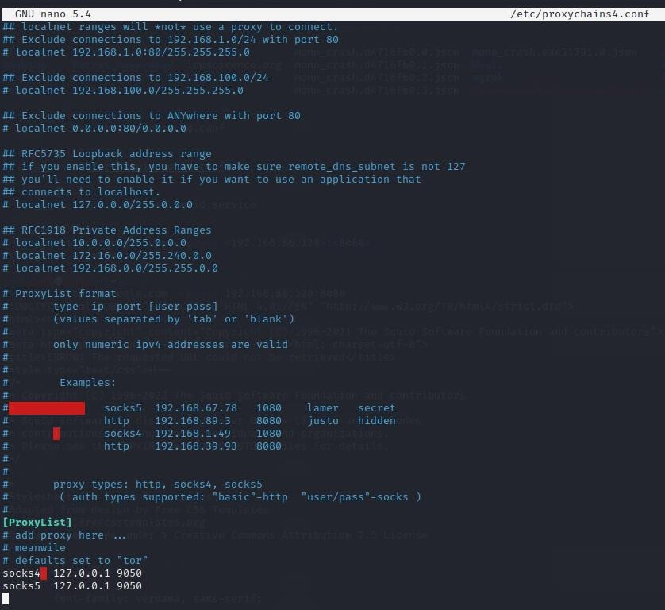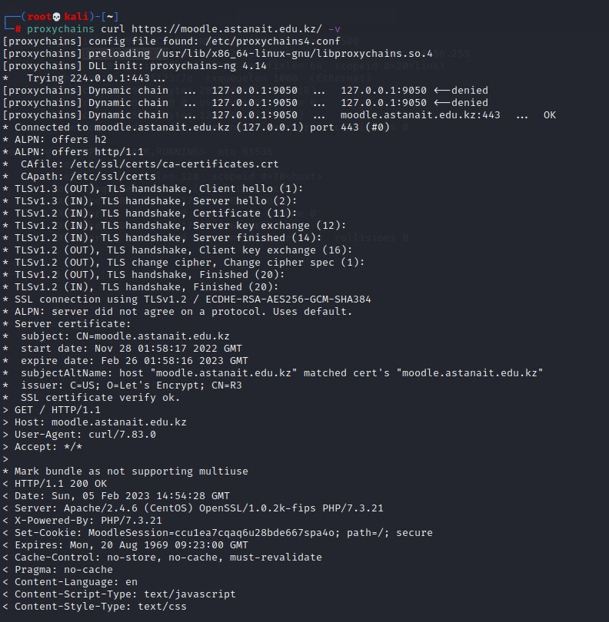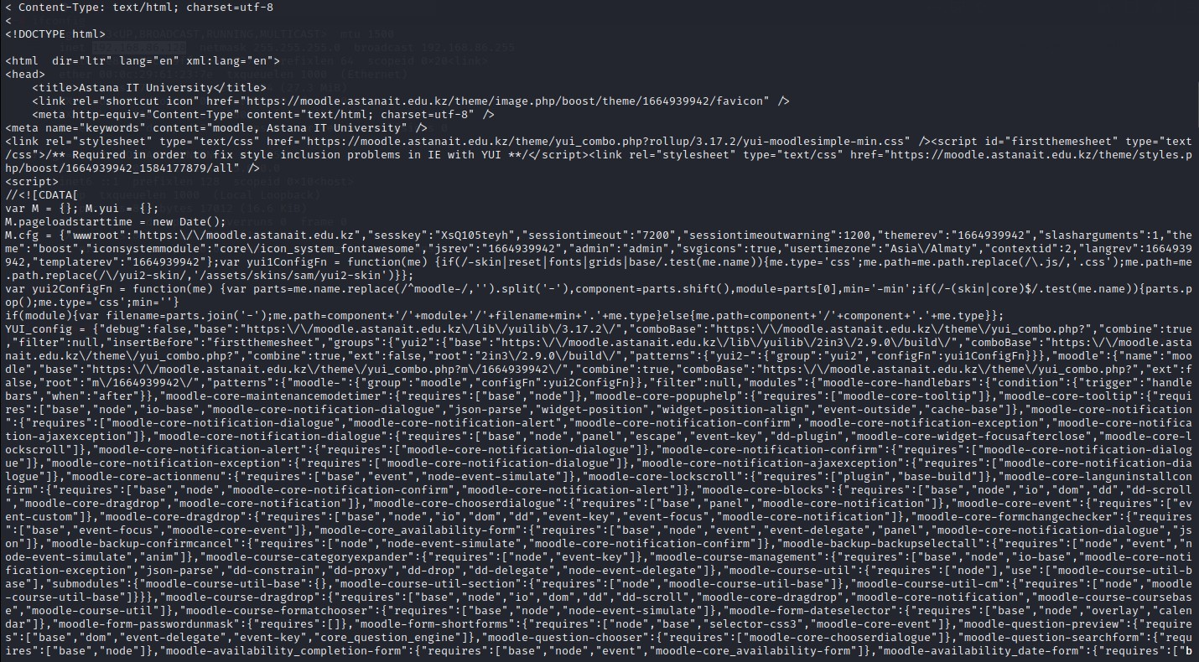

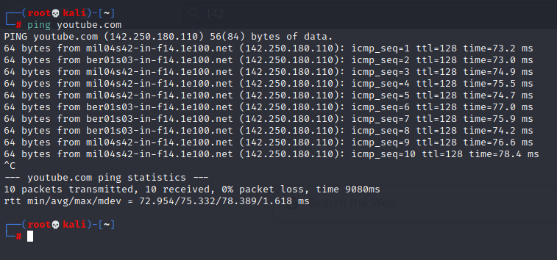

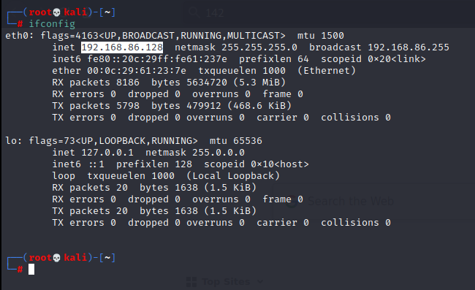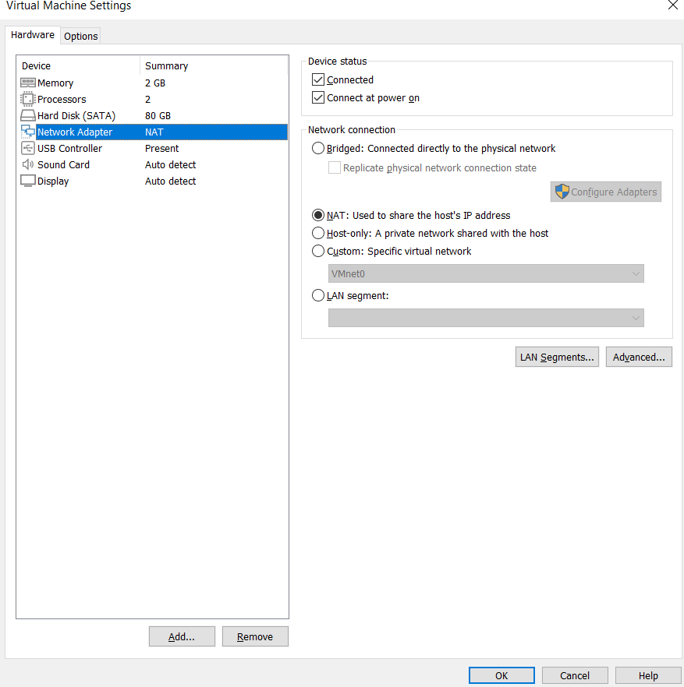

**NAT Connection:**

1. **The virtual machine is assigned a private IP address, and a NAT gateway is used to translate the private IP address to a public IP address.**
2. **This allows the virtual machine to access the Internet while preserving the limited number of public IP addresses.**
3. **NAT is commonly used in home networks and virtual private clouds.**

**And we can also verify the network to check internet connection on our OS with NAT by using ping command:**

**Every our packets were sent successfully!**

**Proxy Server Connection:**

1. **A proxy server acts as an intermediary between the virtual machine and the Internet.**
2. **The virtual machine sends its Internet requests to the proxy server, which then makes the requests on behalf of the virtual machine.**
3. **The proxy server may provide additional security and ﬁltering features, such as blocking certain types of Internet traffic.**

**Here, we used curl command to see website moodle.astanait.edu.kz with proxychain that changes our real ip address in proxy server and send with another IP address.**

Task 3:

Screenshots of the code compilation result:

**To create a simple kernel module in Kali Linux**

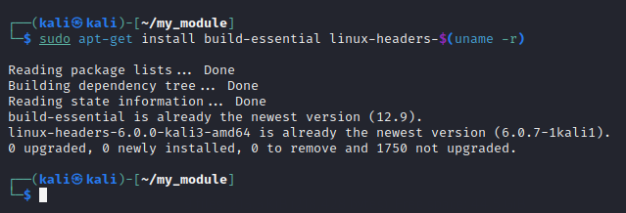**First, install the necessary packages for kernel module development**

**Then we created .c ﬁle to execute our code to add our kernel module!**

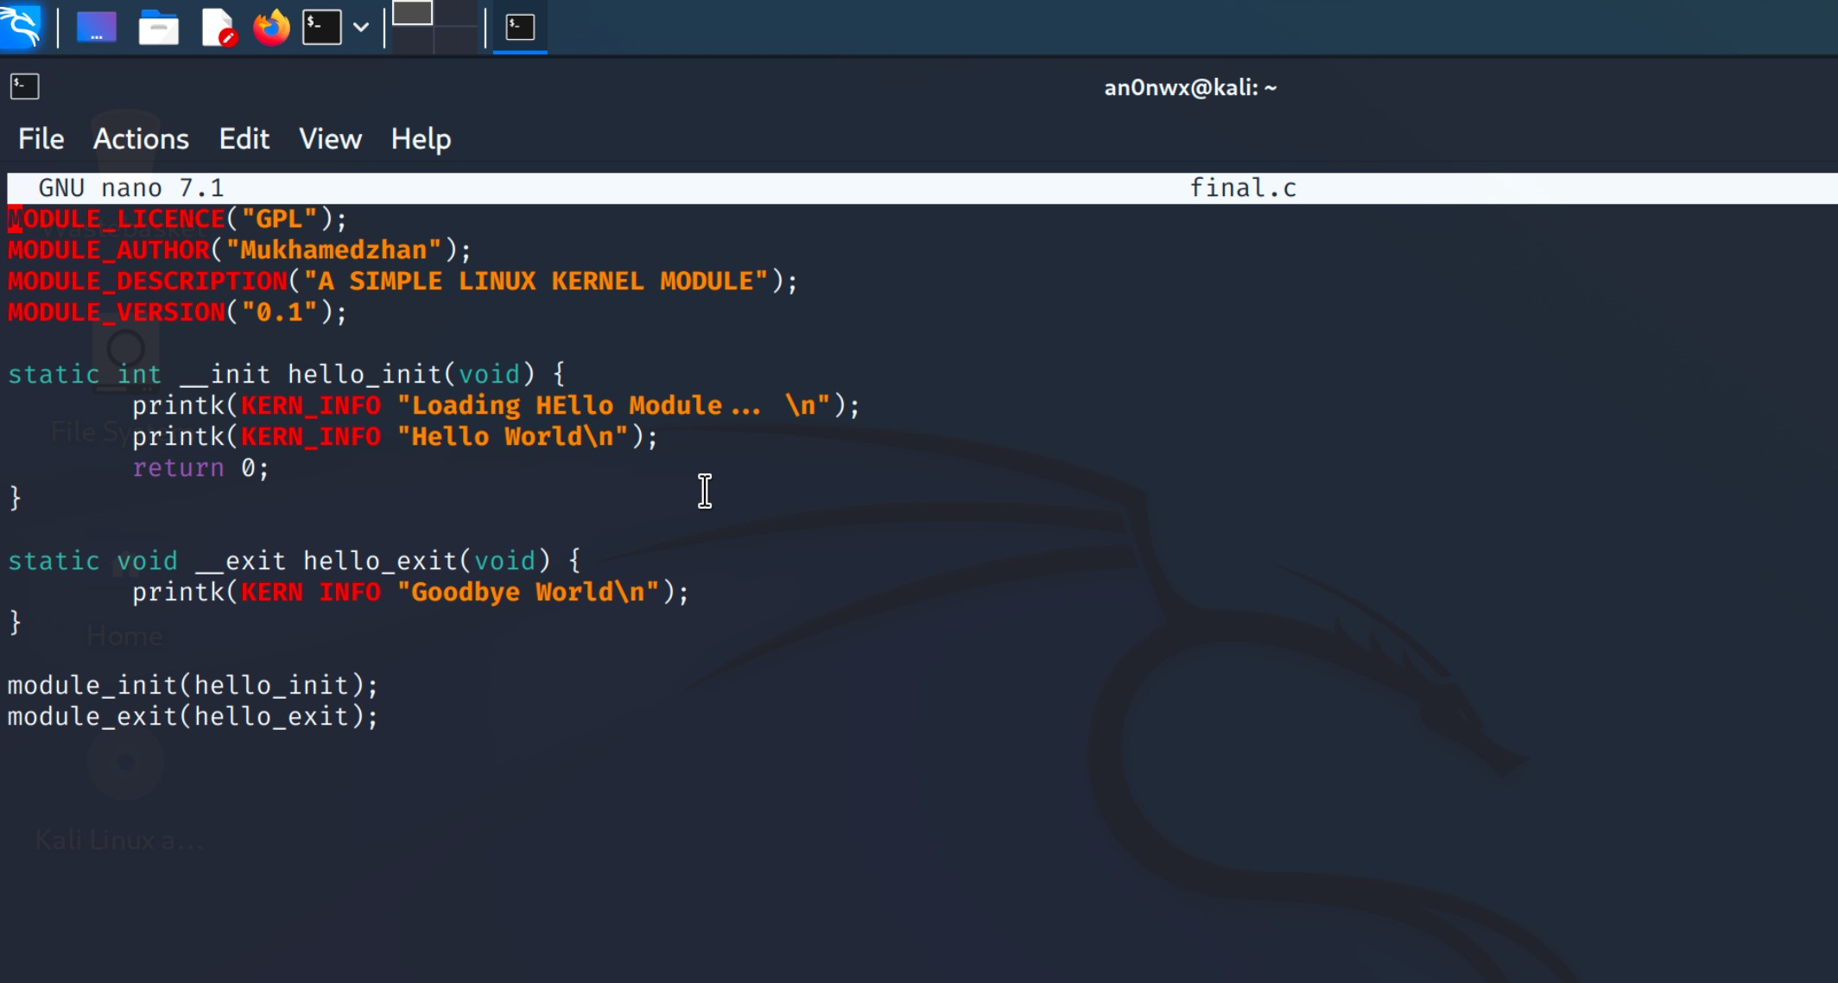

**The correct path to the Linux kernel headers should be speciﬁed in the Makeﬁle to build process for your kernel module without any error!**

**Then loaded the module into the kernel. And wee can verify that the module has been loaded by using lsmod | grep my_module and it shows us ourmodule.**

**Here proof about adding our module to kernel. I removed it, then when show it again here already no my_module kernel module.**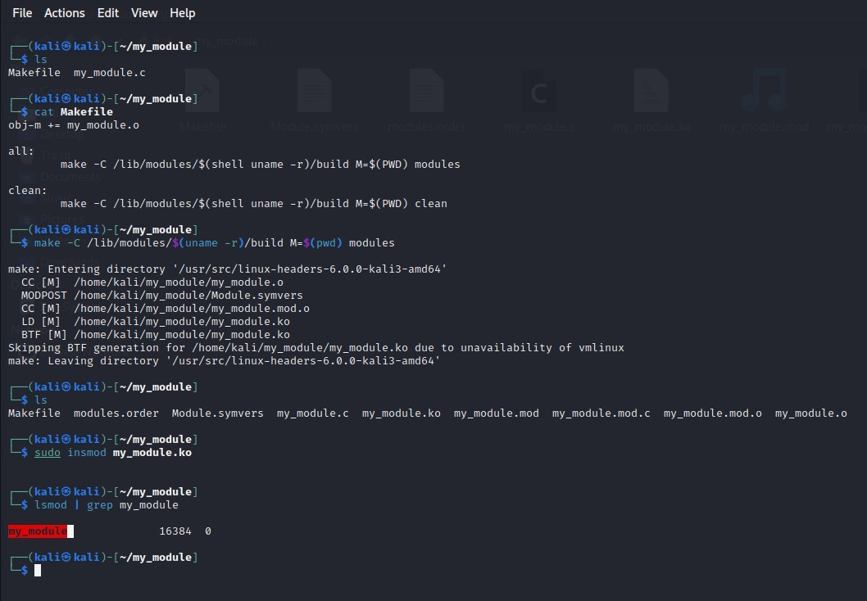

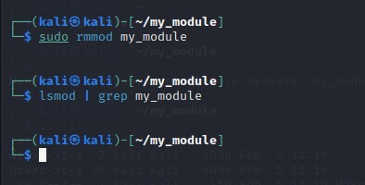

**Creating a kernel module has several advantages, including:**

**Increased performance, better resource utilization, improved system functionality, improved security and so on.**